✴

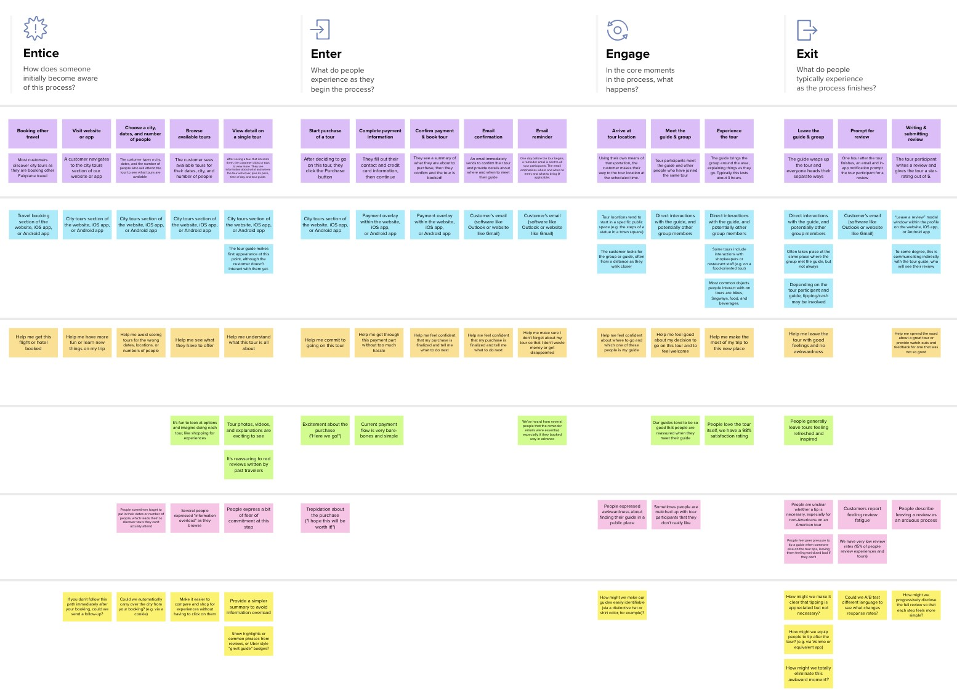

**Template**



Intelligent Vehicle Damage Assessment and Cost Estimator for Insurance Companies

**TIP**

As you add steps to the experience, move each these “Five Es” the left or right depending on the scenario you are documenting.

Narrow your focus to a specific scenario or process within an existing product or service. In the **Steps** row, document the step-by-step process someone typically experiences, then add detail to each of the other rows.

Customer experience journey map

|  |  |  |  |  |  |
| --- | --- | --- | --- | --- | --- |
| **SCENARIO**  **Browsing, booking, attending, and rating a local city tour** | **Entice**  How does someone initially become aware of this process? | **Enter**  What do people experience as they begin the process? | **Engage**  In the core moments in the process, what happens? | **Exit**  What do people typically experience  as the process finishes? | **Extend**  What happens after the experience is over? |
| **Steps**  What does the person (or group) typically experience? | **Customer visit User has Browser for**  **application or registered the available**  **app application Feature**  The customer can enter Most of customers Customer sees  the website and access discover vehicle has Damaged and vehicle the feature, and then the repair costs are available user can resolve the damage and fnd out and also look at the  issue the damage part extent of damage | **The car damage The person frst images was easy to registered or login**  **upload that to**  **application the application**  There are pictures Person application It is easy to tow to  specifc damaged interface is said to  areas on the vehicle be user friendly | **No Need**  **for Immediate Create a Model Arrive at**  **manual Result Process web page**  **process**  Customer should visit  The damage detection Report is analyzed Once the photo is the website for  manual process takes andshown uploaded the model  overtime based on immediately start it work to insurance purpose to  analyze based on  senario without any delay datasets estimate the amount of  damaged parts | **Logout from create a Good**  **Portal Report**  The user Logout their The report  session accuracy  from the website should be high | **Personalized customer**  **Parts modify offers personalized recommendations**  recommendation  systems, The report  which the customer may accuracy  experience via better should be high  personalization |
| **Interactions**  What interactions do they have at each step along the way?  **People:** Who do they see or talk to?  **Places:** Where are they?  **Things:** What digital touchpoints or physical objects would they use? | The Insurance Claim The Website or software the website,  makes  Register section of the frst appearance at this iOS app,  website, iOS app, point, although the  or Android app customer doesn't or Android app  interact with them yet. | THINGS:Digital stuff: PLACE:That means  PEOPLE:People were talking Application  about the application camera insures internet access and  and it is easy to or cell phone and application on the website  EX: ILTakeCare Insurance  insure the vehicle computers App | Direct interactions This is automatic  with the insurance car analyze  companies and damage so they need not to do  model detection anything in this | Logout using theButton | Help me have more Recommendations Customer can  details or learn new span across website,  things on my iOS app, or Android think its very  Insurance claim app complicated |
| **Goals & motivations**  At each step, what is a person’s primary goal or motivation? (“Help me...” or “Help me avoid...”) | Help me have more Help me  details or learn new Help me see what understand what  things on my they have to offer this insurance claim  Insurance claim is all about | Now a days the insurance The process is  company claims that the customer saving  customer has been cheated time,  so this method is very useful  for the customer energy and Fatigue | The Time Help me feel confdent  consumption about the how to  should be valid obtain money | Should give cost based onthe brand ofthe car | Help the user see what they  could be doing next |
| **Positive moments**  What steps does a typical person find enjoyable, productive, fun, motivating, delightful, or exciting? | The customer This is an auspicious entire information time to send internal will damage information  be notifed to the customer | The customer This is an auspicious entire information time to send internal will damage information  be notifed to the customer | Image is not stored in  anyother database once The Feature which  they are provided by the  analyzedhence their portal may them  data is secure | Feel free because of manual work tension | People like looking back on their past process of insurance claim |
| **Negative moments**  What steps does a typical person find frustrating, confusing, angering, costly, or time-consuming? | The customer angry The customer was for claim leakage checking type of  and not show they damage and  damage repair cost estimation | Sometimes the Some inherent  server cannot damages cannot be  reach that server analyzed in that process | People love the online insurance claim  itself, we have a 70% satisfaction rating |  |  |
| **Areas of opportunity**  How might we make each step better? What ideas do we have? What have others suggested? | we can implement Provide a simpler  the user convenient summary to avoid  webservice and information  android overload | Every step is connected I am recommending  with customer and feld update app for  workers in friendly chatbox option in  relationship that app  A recommendation for It is a pioneer in this app is to improve that feld the most user-friendly  designs in that app |  |  | How might we help people celebrate and remember things they've done in the past? |

Use this framework to better understand customer needs, motivations, and obstacles by illustrating a key scenario or process from start to finish.



When possible, use this map to document and summarize interviews and observations with real people rather than relying on your hunches or assumptions.



Created in partnership with



[**Share template feedback**](https://muralco.typeform.com/to/CiqaHVat?typeform-source=app.mural.co)

**Need some inspiration?**

|  |  |  |  |  |  |  |  |  |
| --- | --- | --- | --- | --- | --- | --- | --- | --- |
|  |  |  |  |  |  |  |  |  |
|  |  |  |  | |  |  |  |  |

|  |  |  |  |  |  |  |  |  |
| --- | --- | --- | --- | --- | --- | --- | --- | --- |
|  |  |  |  |  |  |  |  |  |
|  |  |  |  | |  |  |  |  |



See a finished version of this template to kickstart your work.

[**Open example**](https://app.mural.co/template/f59f644b-b4b4-47b5-9ed6-3a8c71ceb612/896b31fe-5597-40ef-9b06-3811a1a45ace)